**Part 2 - Bootstrap Installation and Utilization**

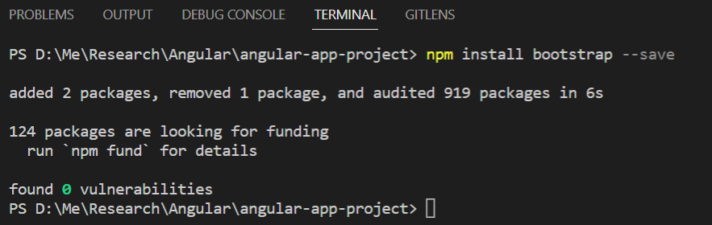

Once bootstrap has installed, please check it out at package.json like this below image

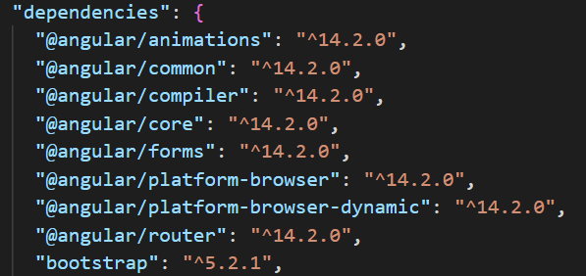

Open angular.json file and register bootstrap.min.js

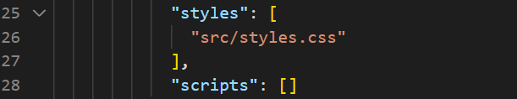



Modify several files

1. nav-bar.component.html
2. property-card (all files .css .ts .html)
3. app-component.html

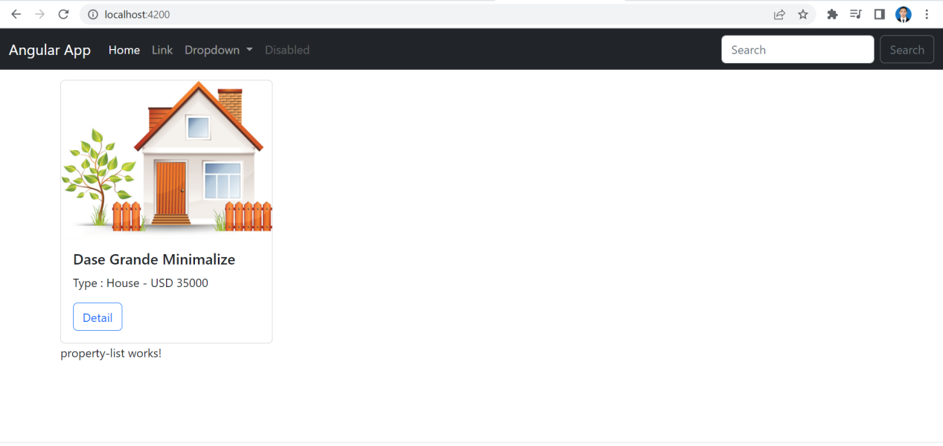

Reference

<https://www.youtube.com/watch?v=gj6f-asv3wM&list=PL_NVFNExoAxclqXo9fLAeP0G2Qp56Fu8C&index=6>